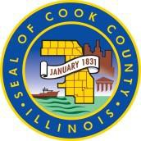

July 19, 2021
EDAC Planning and Development Sub-Committee
Microsoft Teams Meeting
1 872-215-6022 Conference ID: 117 808 224#
9:15 PM – 10:15 AM

Agenda:

- Welcome – Sharon Legenza and Andy Geer Subcommittee Co-Chairs

- Review/Approval of Minutes from Last Subcommittee Meeting (March 17, 2021)

- Informational Items

- Assessment of Fair Housing Update

- 2021 Planning Discussion - Equity Fund, ARPA, ERA1 & 2 and HUD/CARES Act Funding

- Action Items

2021 Annual Action Plan for Cook County 2021 HUD Entitlement Grants

- including CDBG Capital Project Recommendations (PY’21)

- Brief Presentation by Senior Management
- Discussion
- Public Comments
- Request for Recommendation of Approval

- Public Comment

- Adjournment

